Questions and Comments

1. **It would be better if the thesis included a definition for PSPACE and PSPACE hard too since Covering Cycle Oracle is PSPACE-hard.**

Regarding computational complexity theory, I want to learn more about it. Can you please recommend some references?

1. **Page 156, Algorithm 14, line 4 (shouldn’t it be min Ri and min Ui)?**
2. **I have a doubt regarding missing detection rate**, in Chapter 4 it is said that

“The simulations for real life case (Expo) show that the optimal patrolling strategy coincides with such fixed placement even under false negatives rates of at least approximately equals to 0.3.” –quote, page 101 Proof (Proposition 4.11)

Yet in chapter 5, “If missing detection rate is greater than 0, any placement-based strategy will fail to capture attacks in the occurrence of a false negative.” Quote- page 108 Proof (Proposition 5.2)

Again with theorem 5.5’s proof “Every patrolling strategy inducing a support with less than two targets is weakly dominated by a static placement strategy that is a patrolling strategy with a singleton support.” Quote - Page 112-113, it has proof that for 1 target, A will always be captured.

**So I think page 108 should mention the number of targets.**

1. **Can I know more about SUQR attacker?** (found it in Teamcore usc homepage but only saw as adversary behaviour model)

Moreover, the thesis only compared Stackelberg attacker with stochastic attaker later in 8.4 Identifying Attacker (Can we make Proof with SUQR too)?

1. **I can’t understand this particular portion.**

In page 110, Constraint 5.7 is defined like this

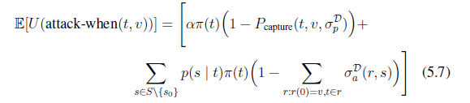

And at page 117, it is said that when we have a covering cyle, the target in the support will be fully protected and Pcapture is 1.

So when P capture is 1, wouldn’t it become 0 for Pcapture part of constraint 5.7? Due to this, I could not rewrite this into the constraints shown in page 117 and 118.

1. Question regarding with future research suggestion: for introducing false positives, I think it should not matter to the protection if the graph has a covering cycle and not unitary graph. Is it true to conclude like that?